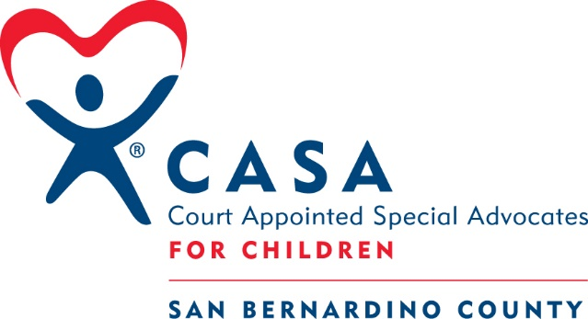

OCTOBER –– Hybrid Training - San Bernardino
Sat. 10/7 – 10am to 4:30pm – In-Person

Wed. 10/11 - 6pm to 9pm – Virtual

Wed. 10/18 – 6pm to 9pm – Virtual

Sat. 10/ 21– 10am to 4:30pm – In-Person

Fri. 10/27 – Swear-in –Morning Time TBD – In-Person

November – Hybrid Training - Apple Valley
Wed 11/1 – 3pm to 6pm – In-person
Mon 11/6 – 3pm to 6pm – Virtual
Tue. 11/7 – 3pm to 6pm – Virtual
Wed. 11/8 – 3pm to 6pm – In-person
Tue. 11/14 – 3pm to 6pm - Virtual
Wed. 11/15 – 3pm to 6pm – In-person
Swear in – Fri 11/17 – 7:30 am – 10am

